## Garden management

1. **Virtual reality and 3D simulation technology applications**: The paper “Virtual Reality Design and Implementation of Interactive Garden Landscapes” demonstrates the application of virtual reality technology in garden landscape design, emphasizing the importance of 3D models and real-time rendering. The study uses the OpenSceneGraph graphics rendering engine to visualize 3D landscape models and parameter control of spatial layouts, which provides users with an interactive 3D scene browsing experience that is very suitable for your platform.
2. **GIS and multi-sensor technology**: In the paper “Application of GIS and multi-sensor technology in green urban garden landscape design,” GIS technology is used for data query and analysis, terrain analysis, hydrological analysis, etc. These technologies can help users to process and display geographic information more accurately when designing gardens, thereby improving the accuracy and practicality of the design.
3. **Three-dimensional simulated garden landscape design method**: The paper “Three-dimensional simulated garden landscape design method based on virtual simulation technology” studies the combination of virtual simulation technology and the traditional three-dimensional simulated garden landscape design method. By constructing a three-dimensional garden landscape simulation system, the accuracy of the design method is improved, which provides technical support for designing more detailed and vivid garden landscapes.

There are three related technologies in garden design:

1. VR

allows users to view and interact with the garden environment in real time, so as to better understand the layout and design intent（Zhang, Song, & QuanQi, 2021）.

2. GIS and Multisensor Technology

GIS technology integrates and manages large amounts of spatial data through a geographic information system, helping designers to conduct precise terrain analysis, location analysis and ecological assessment（Shen, 2023）.

3. 3D

has constructed a complete 3D garden landscape simulation system, which realizes the whole process of digitalization from sketch to detailed design, including terrain design, planning design and plant layout, etc ( Chen & Wang, 2022）.

The application of these technologies has made garden and landscape design more precise, interactive and customer-friendly, greatly improving the quality of design and user satisfaction.

In terms of social aspects,

we found an app called Meals for Monsters:

users can choose their favorite monsters and select what they think is a healthy meal for them to help them achieve their health goals. At the same time, everyone can see the choices and reasons of other users, thus promoting mutual learning and knowledge sharing (Olinsky et al., 2021).

.

This way of working together to achieve goals has inspired our project. like we design together and share the ideas.

Another paper wrote that through the observation of several gardeners of different ages, it was found that without direct interaction, they adjusted their gardens through observation and imitation, gaining experience and knowledge (Maddali, 2020).

Relative website

**Planner 5D**

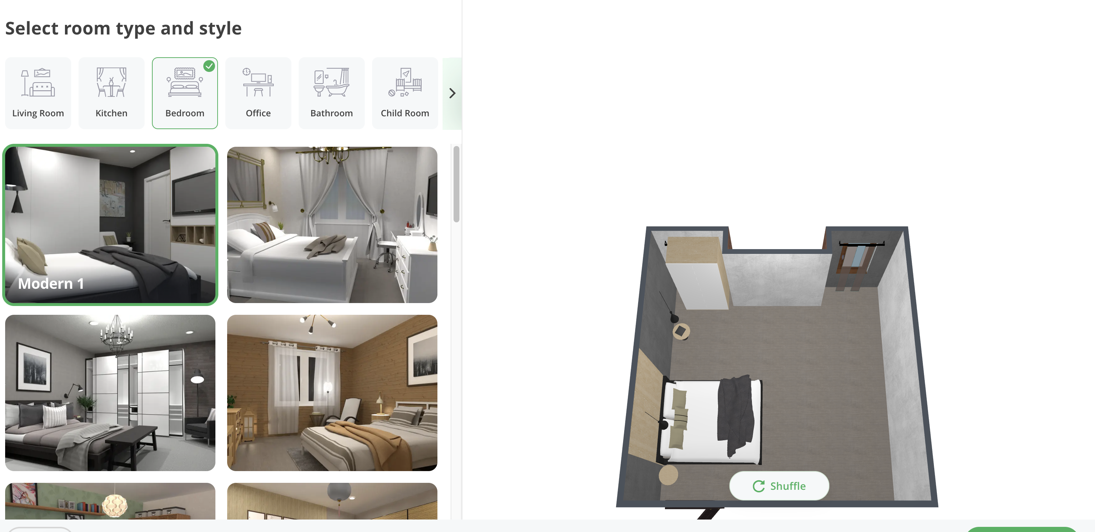

Place some furniture models in the area to see the effect.

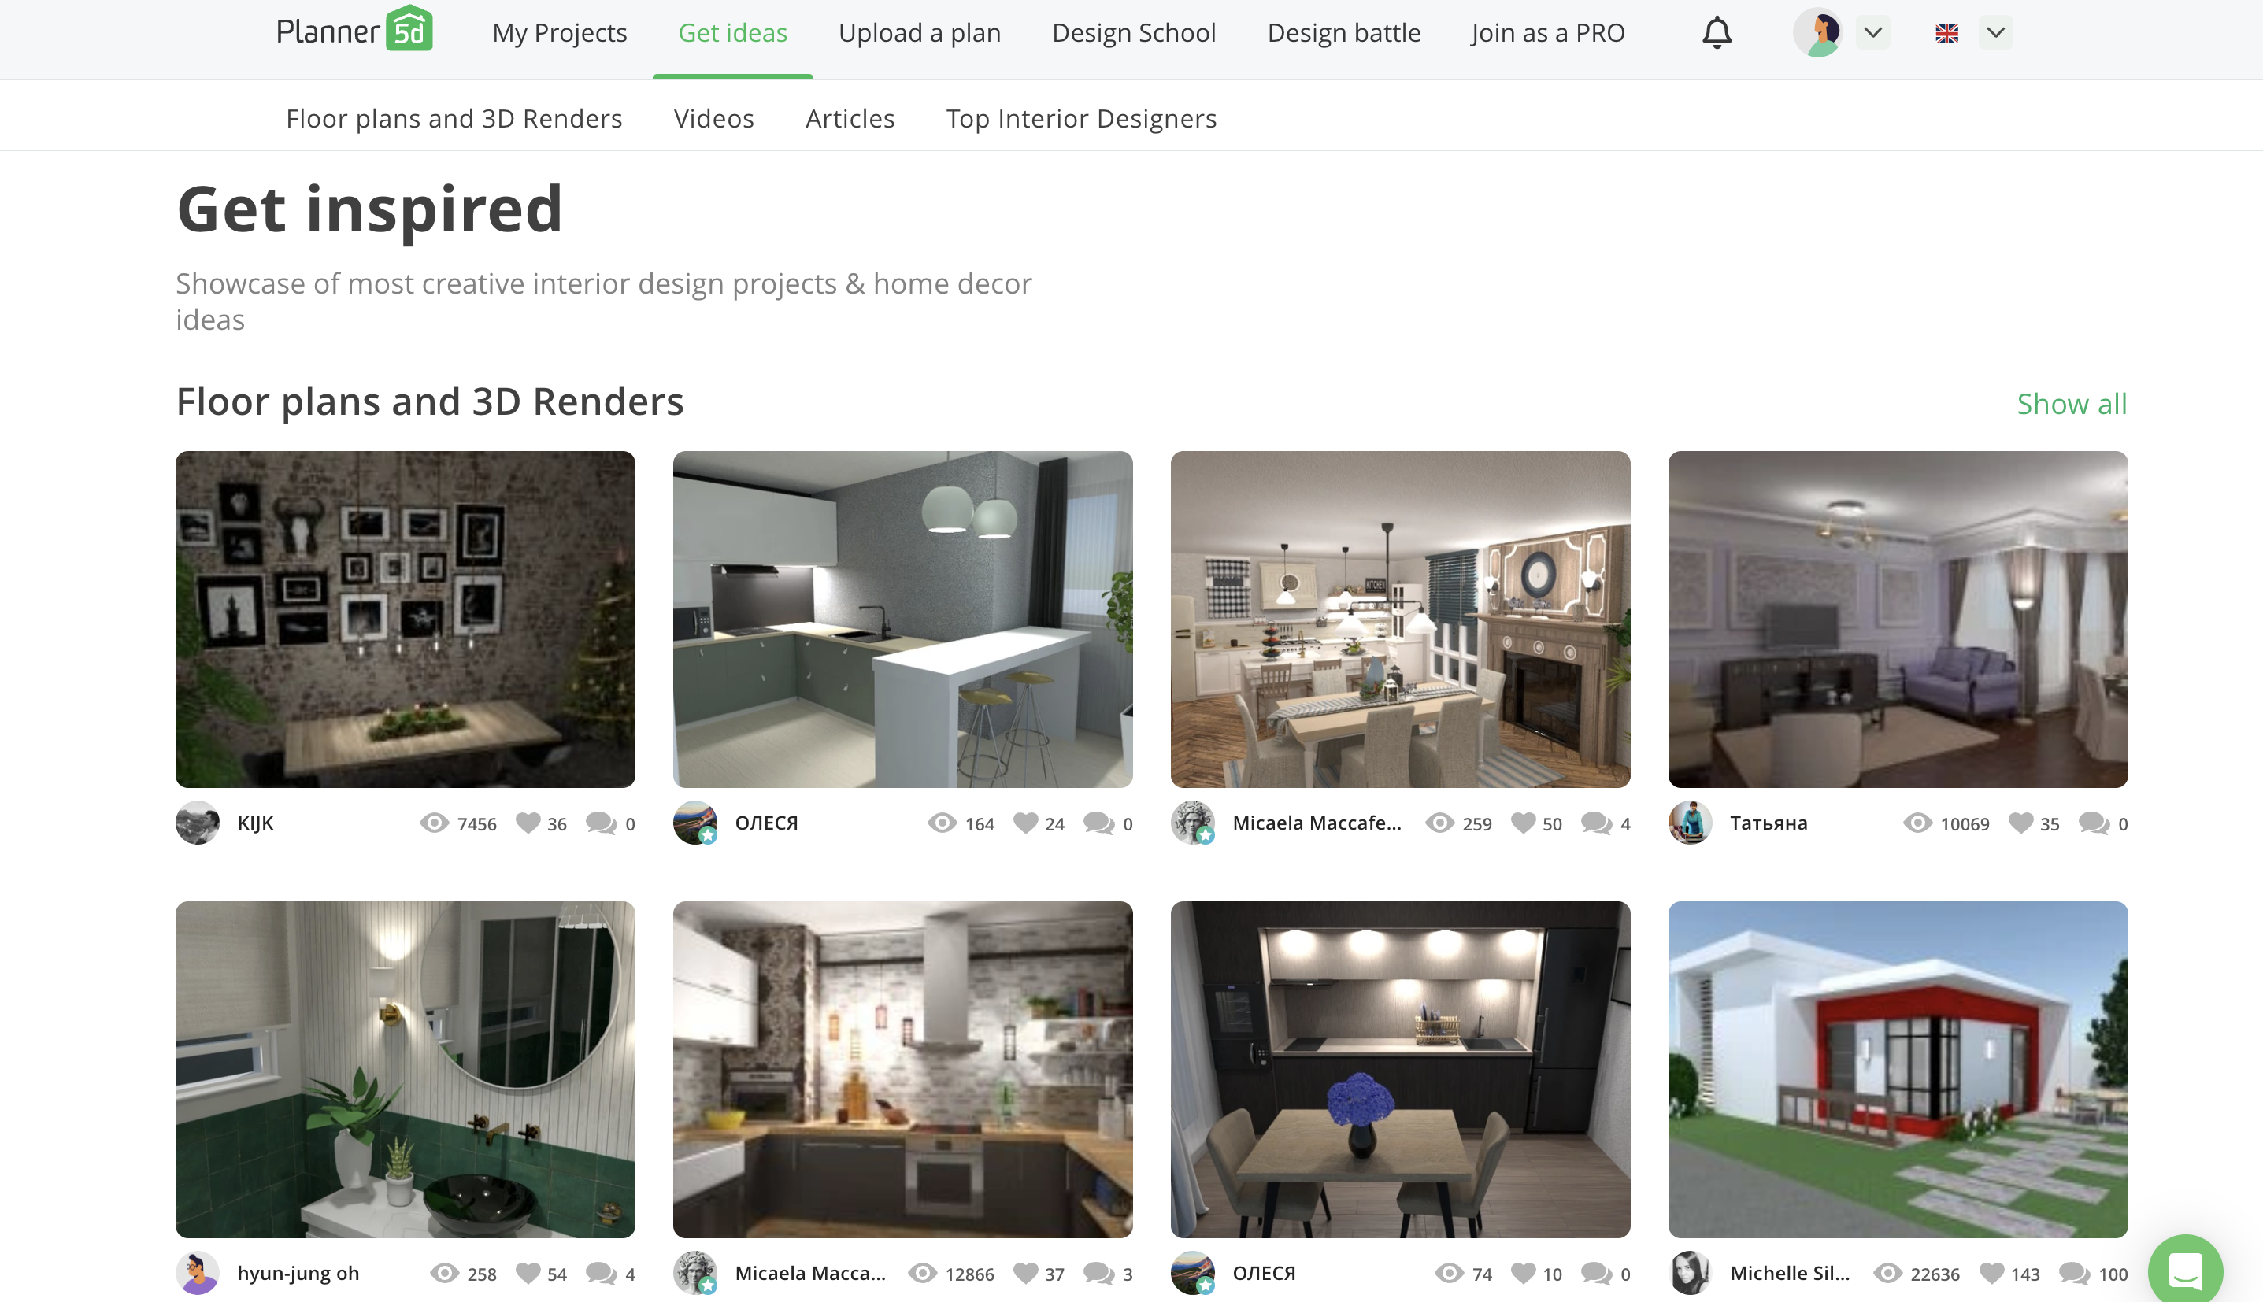

Provide garden design ideas

**Neighborbrite —— AI yard**

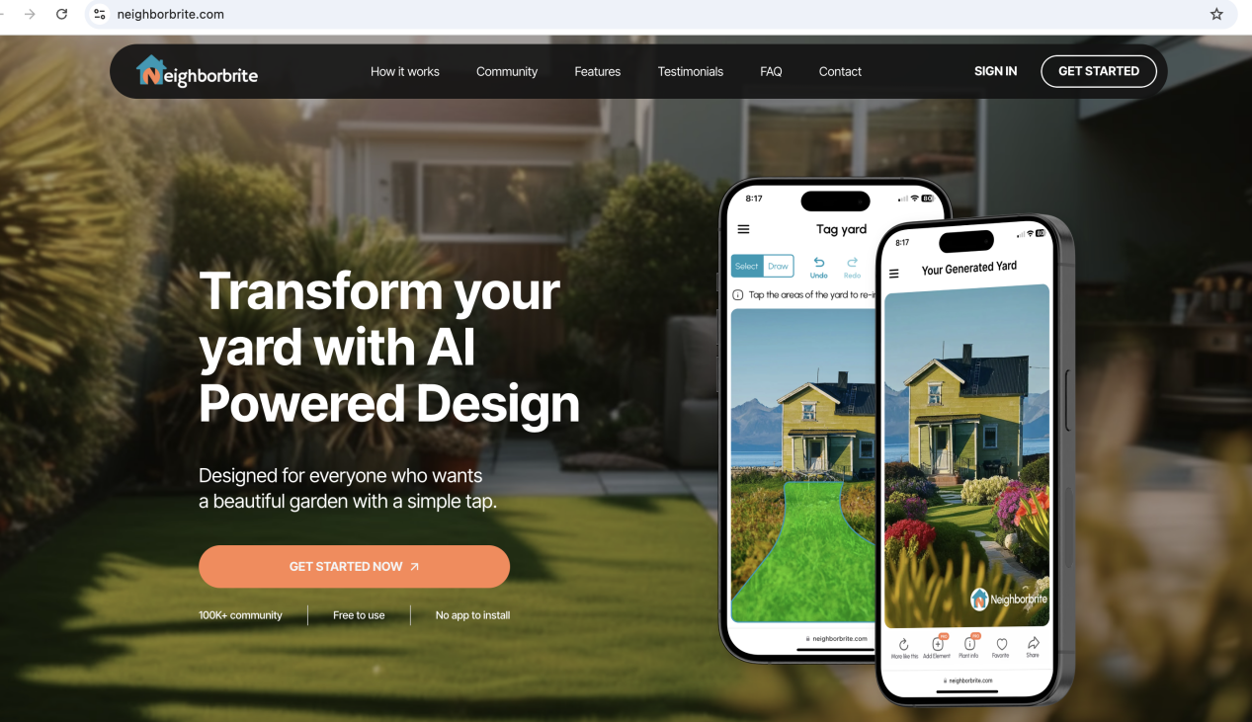

Use AI to generate a suitable garden design

Provides garden design methods, what should pay attention to in different gardens, and the tools and materials needed to complete the design.

**Garden Design**

**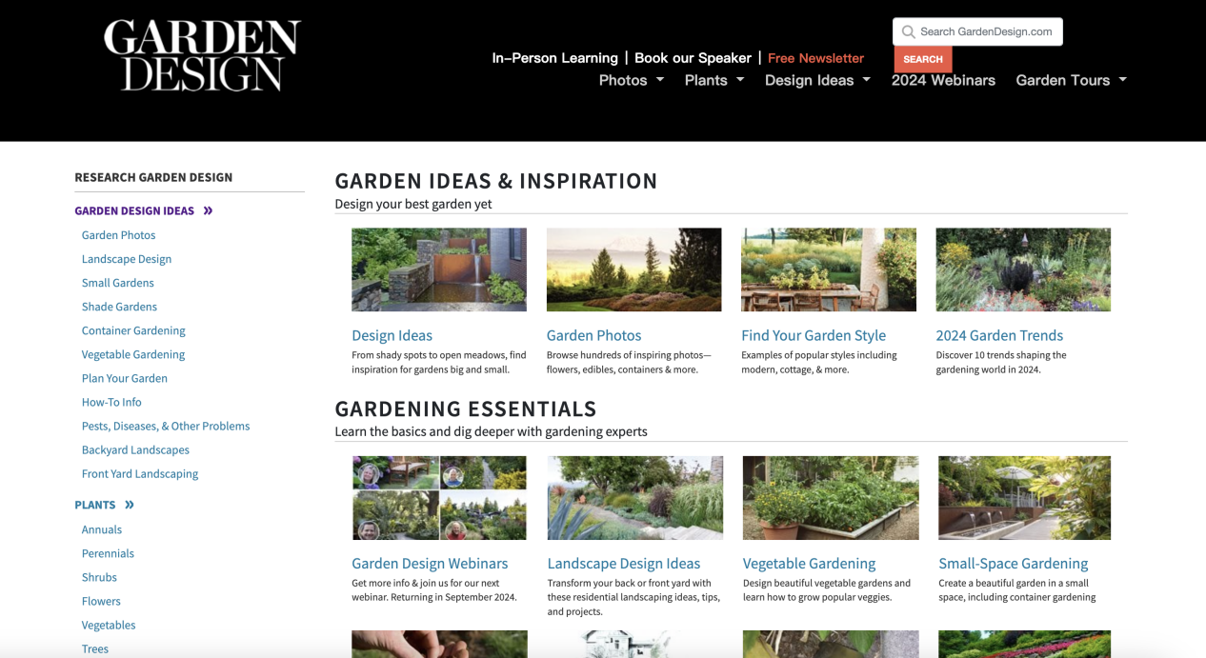**

**Gardensillustrated**

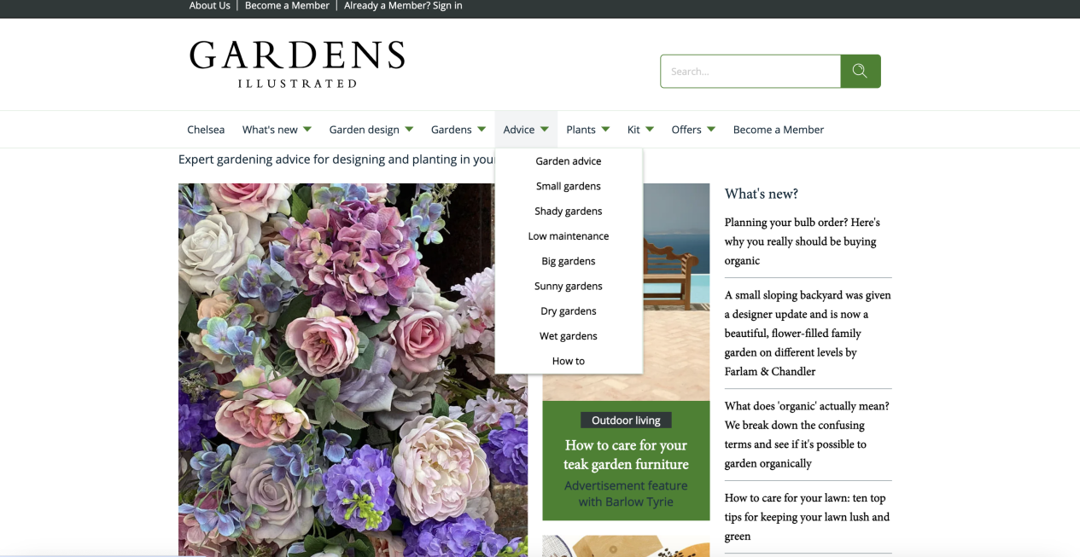

Reference:

Zhang, X., Song, Y., & QuanQi, S. (2021). Virtual Reality Design and Realization of Interactive Garden Landscape. Complexity, 2021https://doi.org/10.1155/2021/6083655

Chen, S., & Wang, X. (2022). Three-Dimensional Simulation Garden Landscape Design Method Based on Virtual Simulation Technology. Wireless Communications & Mobile Computing (Online), 2022https://doi.org/10.1155/2022/4804256

Shen, D. (2023). Application of GIS and Multisensor Technology in Green Urban Garden Landscape Design. Journal of Sensors, 2023(1). <https://doi.org/10.1155/2023/9730980>

Olinsky, S., Desai, P. M., Heitkemper, E., Turkay, S., Mitchell, E. G., Mamykina, L., & Hwang, M. (2021). Meals for Monsters: a Mobile Application for the Feasibility of Gaming and Social Mechanisms. In CHI Conference on Human Factors in Computing Systems Extended Abstracts (CHI ’21 Extended Abstracts), May 8–13, 2021, Yokohama, Japan. ACM, New York, NY, USA, 9 pages. [https://doi.org/10.1145/3411763.3451789](https://doi.org/10.1145/3411763.3451789" \t "/Users/yinaoyan/Documents\\x/_new)

Maddali, H. T. (2020). Sociality and Skill Sharing in the Garden. Proceedings of the CHI Conference on Human Factors in Computing Systems, 1-17. [https://doi.org/10.1145/3313831.3376246](https://doi.org/10.1145/3313831.3376246" \t "/Users/yinaoyan/Documents\\x/_new)